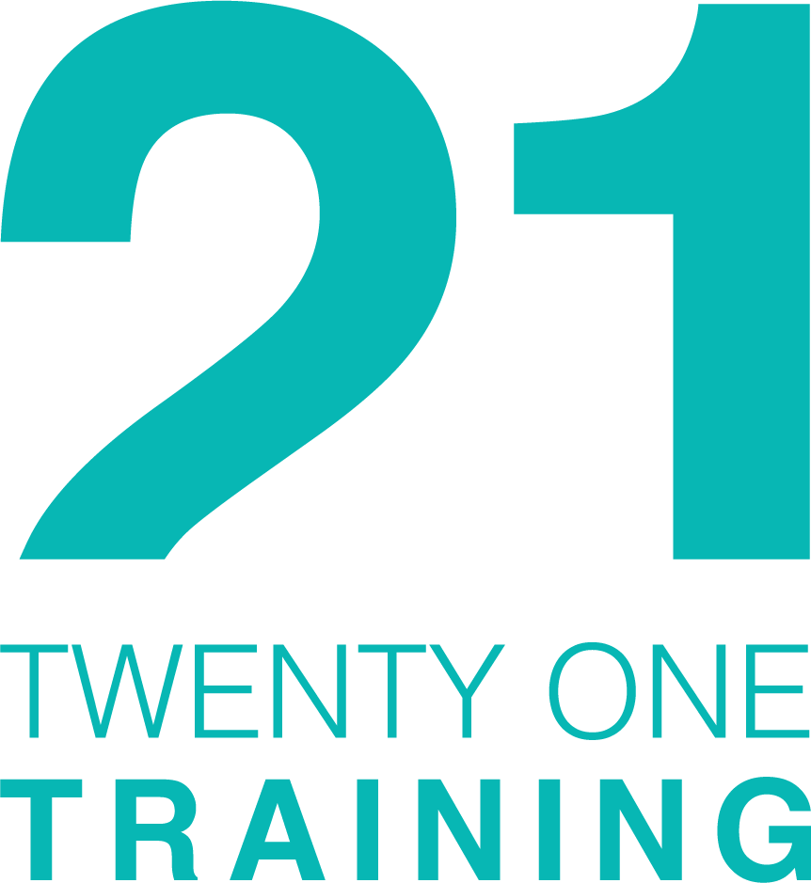

COMMUNITY FAMILY SUPPORT PROGRAMME

Information Booklet

This project is part funded through the Northern Ireland European Social Fund 2014-2020, and the Department for the Economy
What is CFSP?
Community Family Support Programme (CFSP) help individuals / families address the employment, educational, training, health, social and economic issues which are causing problems getting into education, training or employment.

Who is CFSP for?
- Aged 16-74 years old, not in education or training, unemployed or working under 48 hours / week, to breakdown personal barriers to re-skill, find a new job or increase hours
- Have concerns with health, social problems, housing issues, financial difficulties, or other issues stopping you find suitable education, training or employment
- CFSP is free and voluntary, we ask that you are committed to improving YOUR life, with our help
- Activities are tailored to your specific needs, strengthening support from family members, friends and / or other services.

Which Council areas is CFSP available?
- Causeway Coast & Glens
- Derry City & Strabane
- Fermanagh & Omagh
CFSP is available throughout N. Ireland, contact details for other providers can be found at https://www.nidirect.gov.uk/articles/community-family-support-programme

When is CFSP?
- Start and finish CFSP anytime, we aim for 4 - 6 months - it’s up to you.
- Meet in the family home, public place, library, café, groups or in our office, wherever you feel more comfortable
- Start with the difficulties and work together towards your end goal.
How will CFSP help me?
Whether you have been referred by someone who is working with you or your family, like a support service, a careers advisor, or GP, or if you have contacted us yourself, your journey begins with your designated Family Mentor (FM) who will:
- Phone / text to introduce themselves and arrange a time to meet
- Visit at a time and place that suits you, this initially takes place at the family home, or if you prefer CFSP office or someplace you feel more comfortable
- At the first meeting, the FM will ask some questions about your circumstances, to establish if there are concerns with money, benefits, housing, relationships, health and well-being— this to assess what support you would like, and what we can offer.
- The Family Mentor will ask the Career Mentor (CM) to help when you are ready to start looking for work or education/training opportunities.
- The Career Mentor will discuss previous work history & qualifications, what kind of job or course you are looking for, help with job-searching, contacting employers and finding you work, and plan how we can work together to achieve your goals.
- Both the Family and Career Mentors can also help arrange training through our Facilitators, who offer online training or source courses and training within your local area.

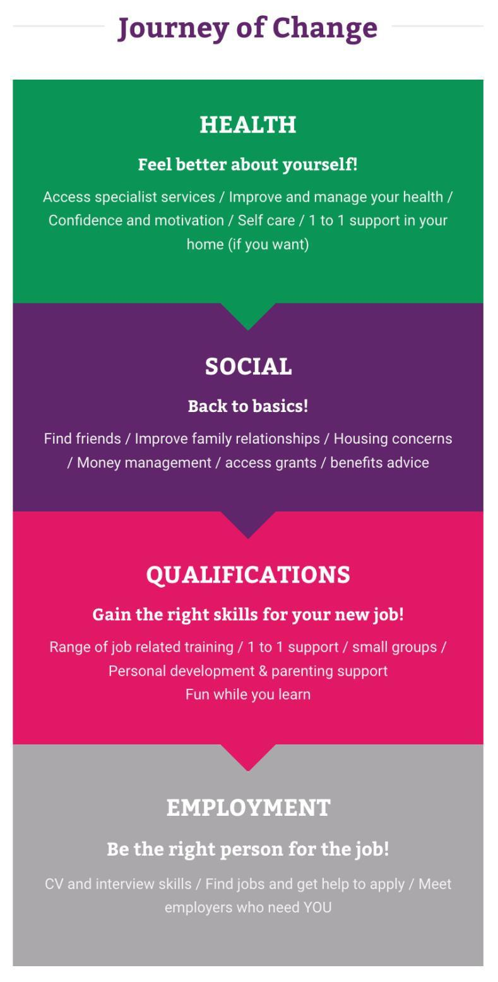
What can CFSP offer me?

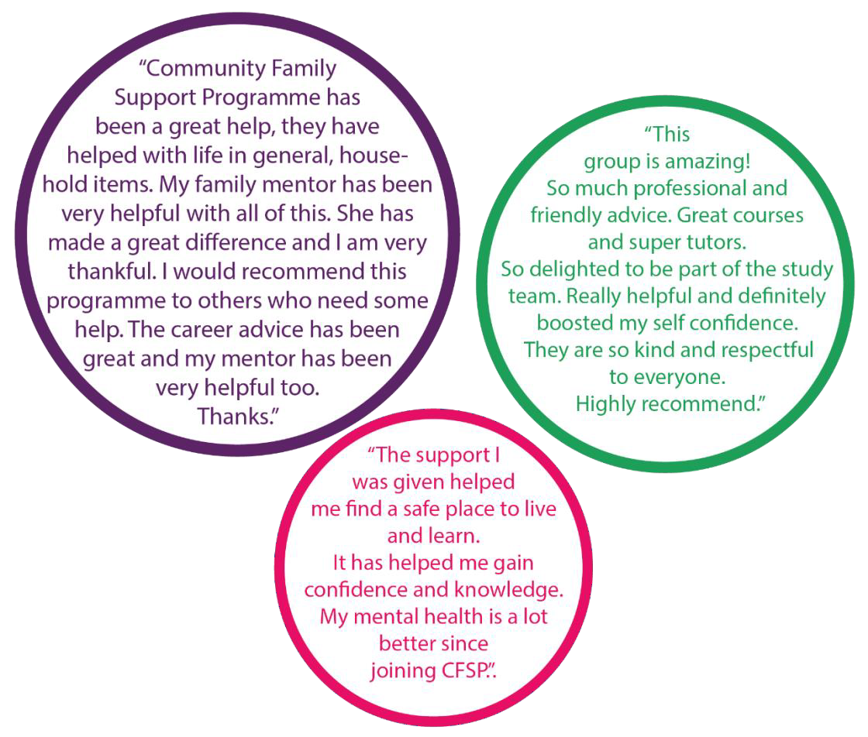
What do participants say about CFSP?

Frequently Asked Questions
Can I join CFSP if I receive benefits?
Yes, we can offer benefit advice and money management skills

How long will I receive support?
You can have support for as long as you need us, we aim for 4-6 months, but occasionally up to one year. If you no longer want our help, just contact your Family, Career Mentor or local office.

What if I want to make a complaint?
You may be contacted by an Area Manager to discuss your experience of CFSP, and if there is anything we can improve. However, if you are unhappy with CFSP, let us know so we resolve the issue as soon as possible. You can do this by contacting the Area Managers Lynda Millar on 07739651301, or Maeve Donaghy 07739651536

I am worried about a member of my family and I don’t know what to do. Can you help?
If you have a concern for the well-being or safety of someone, you should contact the Safeguarding Team in your local area, Lynda or Maeve (see above contact details) or Gemma McClure, the 21 Training Adult Safeguarding Champion on 07926697835.

Anything you disclose to us may be passed to statutory bodies for advice and to ensure appropriate support is given
Will you keep my information confidential?
Our funders require us to record your personal details and document the support we provide; we will keep all your personal information securely both electronic and paper based, and shall only share with other professionals on a need to know basis in order to help you. We are required under the ESF regulations to hold this information until 31/12/2030. You will be asked to sign a data consent form, without agreement you will be unable to avail of CFSP.
The only time we will share information without your permission, is where someone’s well-being or safety is at risk.

Section 75, Equality Monitoring
CFSP is required by our funders - The Department for the Economy & European Social Fund to monitor and review equality under Section 75 of the NI Act 1998; in doing such an anonymous online survey should be completed by all CFSP participants-
https://consultations.nidirect.gov.uk/dfe-eu/cd7e8bd2
No personal identification information will be requested or collected and the survey should take no more than 5 minutes to complete.

21 Training Policies available on request.
Get in touch with us:
Your local CFSP offices are:

Derry / L‘Derry – 028 71225431 & Strabane – 028 71225413
Coleraine - 028 703 26016
Omagh – 028 82440200
Enniskillen – 02866330515

Email: cfsp@21.training

Your designated CFSP team contact details:
Area Manager: Lynda Millar, lmillar@21.training or Maeve Donaghy, mdonaghy@21.training
Project Assistant: Denise Goodwin, dgoodwin@21.training
Area Facilitator: Rebecca Black, rblack@21.training
Family Mentor: Shannon Stanfield, sstanfield@21.training (Derry/Londonderry)
Megan McElhinney, mmcelhinney@21.training (Strabane)

Career Mentor: Jennifer Kane, jkane@21.training (Derry/Londonderry)
Sharon Barrett, sbarrett@21.training (Strabane)

