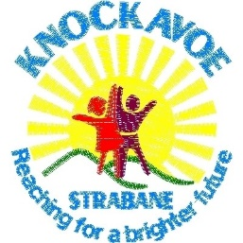
Article 31
Every child has right to relax, to play and to engage in arts and cultural activities.

Article 24
Best possible health . govts must work to provide a good environment so children can stay healthy

In June 2022 Knockavoe School was contacted by Aisling McLaren from Disability Action with regards to discussing the lack of play provision in Strabane.
I organised for Aisling to meet with our Friends of Knockavoe (PTA). We decided the way forward was to speak to the children, hear their voice, and to present our findings to officials.
It was decided that an artist would help the pupils to prepare a project on what they wanted to see for inclusive play provision in Strabane. This presentation of models and pupils voice, I thought, would be more effective in presenting the findings to those who could provide such an area.
The student council worked on talking to each and all pupils in their classes about current play provision, the artist worked on 3D models with some of our pupils in their art classes, a survey was sent to parents asking for their views.
A presentation was put together for Mon 28th Nov 2022. Disability action provided an overview of the ONLINE project. Our choir entertained the audience and the student council presented their views. All elected officials were invited. 2 councillors attended, Raymond Barr (independent) and Dan Kelly (SF) as did Claire Lynch from Derry Strabane District Council – in her role as Children & Young Peoples Coordinator.
I spoke about the provision in Strabane and further afield and what steps we had taken to get to today. Davy Ralston was on site to take photos and a report was written to submit to local newspapers.

Gráinne Dunne
VP
Knockavoe School.

