
Safety Notice
Product Recall: HTI Toys Stretcherz

GOV.UK have advised that HTI Toys Stretcherz products have been withdrawn from the market and recalled from end users by HTI Toys (manufacturer) and the following distributors/retailers: ALDI, Argos, ASDA, B&M, The Entertainer, Home Bargains, Morrisons, Poundland, Smyths Toys, Tesco, TK Maxx/Homesense and The Works.

Product Information

These Stretcherz Toys - Action Figures (Non Powered) are stretch toys filled with sand-like material. They can be used as sensory toys. There are a variety of types of these toys see Product Recall - Stretcherz Toys for photographs. Below is a sample of Stretcherz Toys.

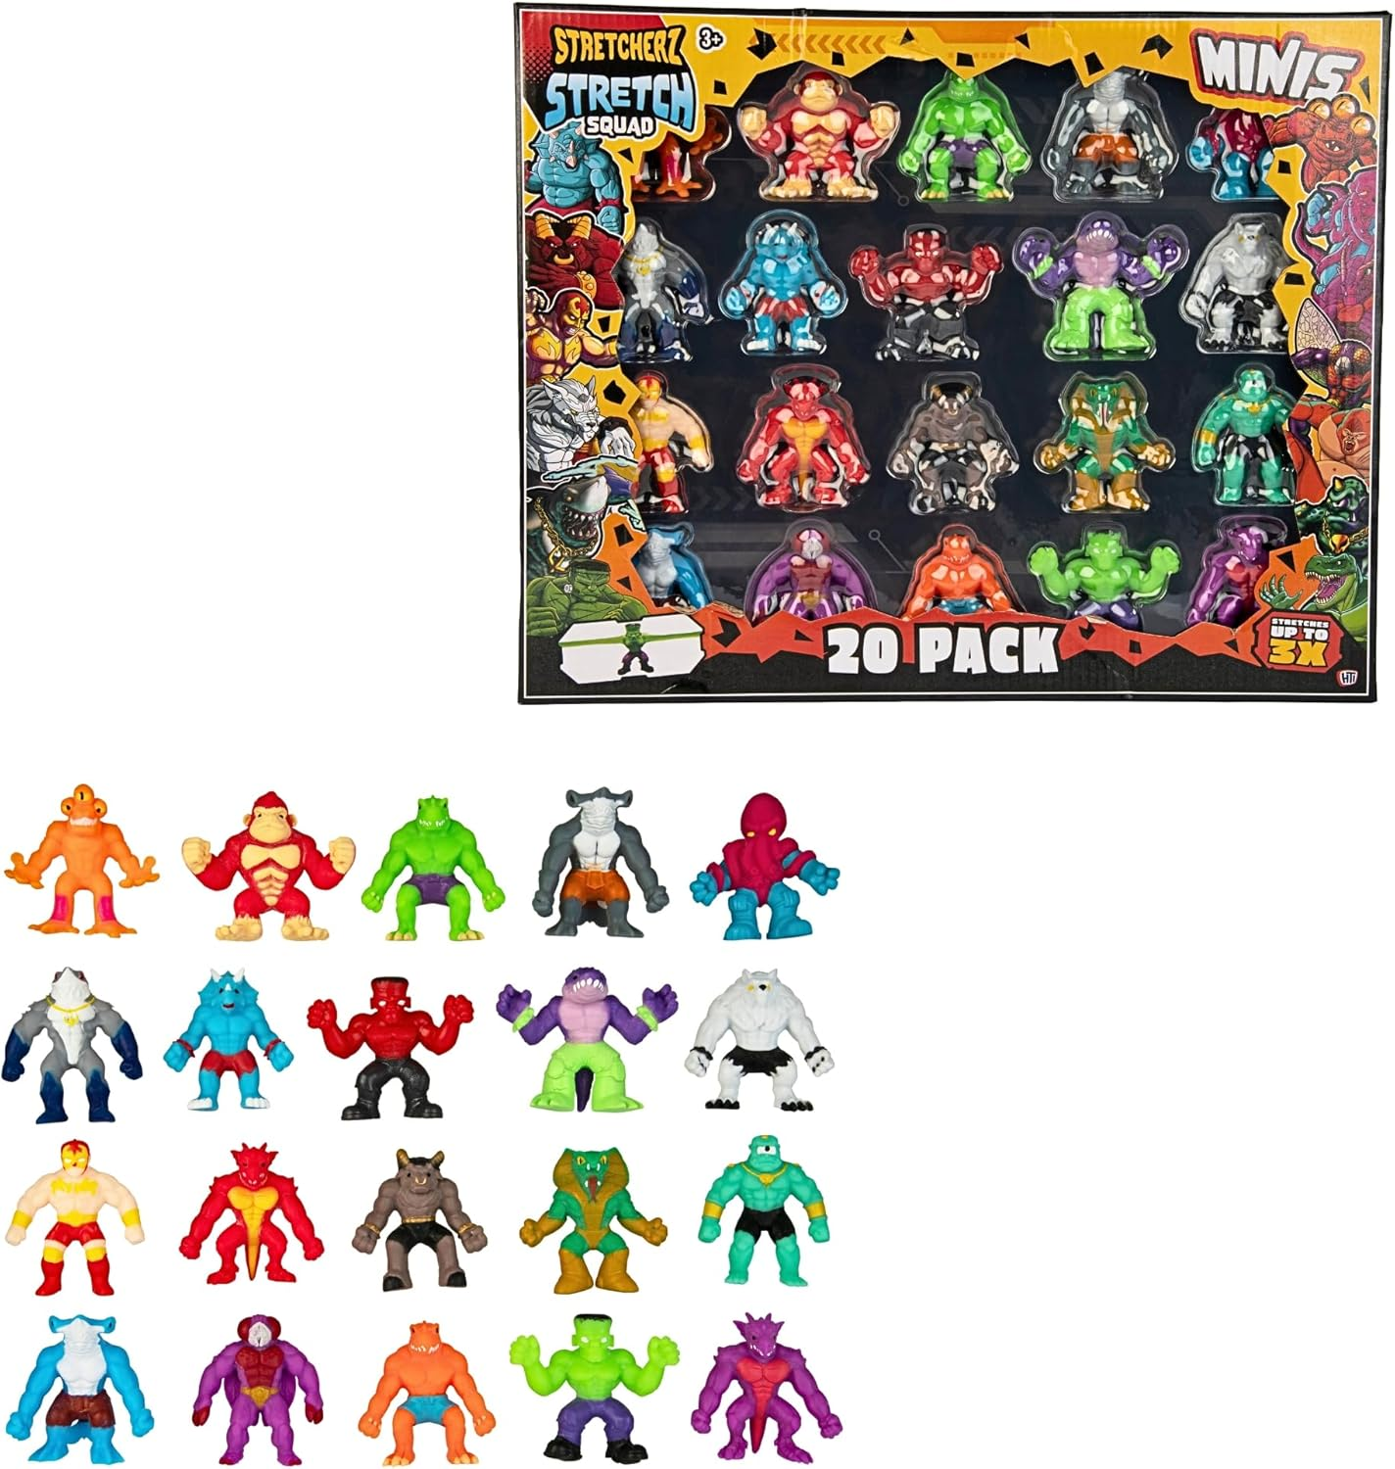

Following this advice the Education Authority (EA) Health and Safety Service has verified that none of the affected products identified by the Gov.UK are listed on the EA Material tender.

Hazard

The product presents a risk to health as the sand may be contaminated with a small quantity of asbestos. Asbestos is a banned substance because it poses a risk to health even at low levels of exposure. The product does not meet the requirements of the Toys (Safety) Regulations 2011.

What you should do now?

Please circulate a copy of this notice to all staff on site.
Check your school for any HTI Toys Stretcherz on site. If you have any of these toys, TAKE THEM OUT OF USE IMMEDIATELY and dispose of them.

Disposal instructions

- Stop using the product immediately.

- If the sand is still in its packaging, place in a heavy-duty plastic bag, double tape it securely, label it clearly and store in a secure location out of the reach of children.

- If the sand has been used, clean up sites where the product was used using wet cloths to avoid generating dust. Wear gloves and a mask. Double bag the sand, gloves, mask and cloths.

- Keep children and other people away from areas where the sand has been used until the area has been cleaned.

- Return the product to the place of purchase for redress. If you are unable to get to the store, please follow the instructions above and dispose of the product in your general household waste.

- Contact the distributor you purchased from for a full refund.

For additional information please go to Product Recall: HTI Toys Stretcherz.

